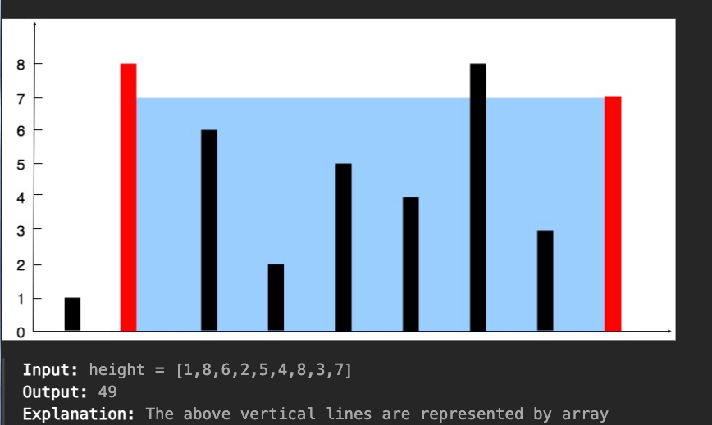

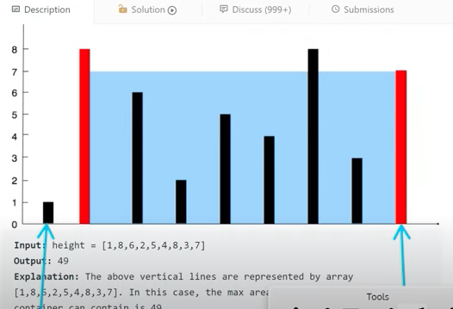

1 X 8 = 8 => 1 x (8-0)= 8

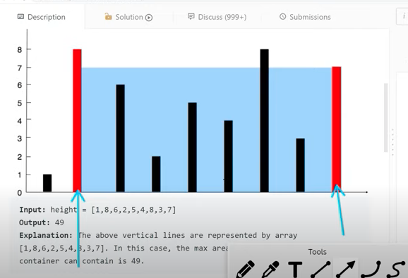

7 x 7 =49 => 7 x (8-1) = 49